**Medals Table**

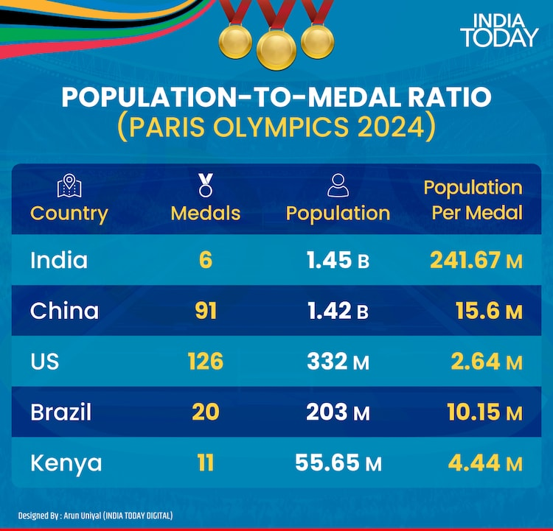

The medal table is based on information provided by the [International Olympic Committee](https://en.wikipedia.org/wiki/International_Olympic_Committee) (IOC) and is consistent with IOC conventional sorting in its published medal tables. The table uses the [Olympic medal table](https://en.wikipedia.org/wiki/Olympic_medal_table) sorting method. By default, the table is ordered by the number of gold medals the athletes from a nation have won, where a nation is an entity represented by a NOC. The number of silver medals is taken into consideration next and then the number of bronze medals. If teams are still tied, equal ranking is given and they are listed alphabetically by their [IOC country code](https://en.wikipedia.org/wiki/List_of_IOC_country_codes).

Events in [boxing](https://en.wikipedia.org/wiki/Boxing_at_the_2024_Summer_Olympics) result in a bronze medal being awarded to each of the two competitors who lose their semi-final matches, as opposed to fighting in a [third place tie breaker](https://en.wikipedia.org/wiki/Third_place_playoff). Other combat sports, which include [judo](https://en.wikipedia.org/wiki/Judo_at_the_2024_Summer_Olympics), [taekwondo](https://en.wikipedia.org/wiki/Taekwondo_at_the_2024_Summer_Olympics), and [wrestling](https://en.wikipedia.org/wiki/Wrestling_at_the_2024_Summer_Olympics), use a [repechage system](https://en.wikipedia.org/wiki/Repechage_system) which also results in two bronze medals being awarded.

In the [men's 100 m breaststroke](https://en.wikipedia.org/wiki/Swimming_at_the_2024_Summer_Olympics_%E2%80%93_Men%27s_100_metre_breaststroke), two silver medals and no bronze medal were awarded due to a tie; in the [women's high jump](https://en.wikipedia.org/wiki/Athletics_at_the_2024_Summer_Olympics_%E2%80%93_Women%27s_high_jump), [men's horizontal bar](https://en.wikipedia.org/wiki/Gymnastics_at_the_2024_Summer_Olympics_%E2%80%93_Men%27s_horizontal_bar), and [women's K-2 500 metres](https://en.wikipedia.org/wiki/Canoeing_at_the_2024_Summer_Olympics_%E2%80%93_Women%27s_K-2_500_metres), two bronze medals were awarded due to ties.